**PROJECT DOCUMENT**

**Name :SVMITHUNAKASH**

**Register number :720722110016**

**Department :B.TECH IT**

**Year :2ND YEAR**

**Project Title :BEST PRACTICES**

**OF LEGACY SYSTEM INTEGRATION**

**WITH MODERN TECHNOLOGIESZ**

**Template Name:**

# STRATEGY BLUEPRINT

**Problem Statement:**

**Legacy Systems Modernization refers to the process of updating or replacing outdated and often complex software systems with modern, efficient, and scalable solutions. This problem statement addresses the challenges associated with maintaining and operating legacy systems, which can hinder an organization's ability to innovate, adapt to changing business needs, and remain competitive in the market.**

**Description: Many organizations rely on outdated technology infrastructure and legacy systems, hindering agility, scalability, and innovation.**

**Objective: Develop a strategy to modernize legacy systems, migrate to cloud-based solutions, and leverage emerging technologies to enhance efficiency and competitiveness**.

**Project description:**

**Project Title: Legacy Systems Modernization* Project Overview:**

**The Legacy Systems Modernization project aims to address the challenges posed by outdated and inefficient software systems within our organization. By modernizing our legacy systems, we seek to improve operational efficiency, enhance security and compliance, enable innovation, and support future growth initiatives.**

**Project Objectives:**

1. **Assess the current state of legacy systems and identify areas for improvement.**
2. **Define a modernization strategy and roadmap aligned with business objectives.**
3. **Select appropriate technologies, platforms, and methodologies for modernization efforts.**
4. **Develop and implement modernized solutions to replace or integrate with legacy systems.**
5. **Enhance user experience and productivity through intuitive interfaces and workflows.**
6. **Optimize cost-effectiveness and resource utilization throughout the modernization process.**
7. **Measure and evaluate the impact of modernization initiatives on business outcomes.**

**Project Phases:**

|  |  |
| --- | --- |
| **Assessment and** | **Planning** |

**:Conduct an assessment of existing legacy systems, including technical debt, performance bottlenecks, and security vulnerabilities. Define a modernization strategy and roadmap based on business priorities and requirements.**

**Technology Selection:Evaluate available technologies and platforms for modernization, considering factors such as scalability, interoperability, and vendor support. Select the most suitable solutions for each aspect of the for each aspect of the modernization project.**

Development and Implementation: Develop and implement modernized solutions according to the defined strategy and roadmap. This may involve building new systems from scratch, migrating data and functionalities, or integrating with third-party applications.

Testing and Quality Assurance: Conduct rigorous testing and quality assurance activities to ensure the reliability, performance, and security of modernized systems. This includes functional testing, integration testing, and security testing.

Deployment and Rollout: Deploy modernized systems into production environments and roll them out to users in a phased approach. Provide training and support to users to facilitate adoption and minimize disruption to business operations

Evaluation and Reflection: Evaluate the outcomes and impact of legacy systems modernization initiatives. Reflect on lessons learned, successes, and areas for improvement to inform future projects and initiatives.

|  |
| --- |
|  |
|

**Worked Template with explanation**

**Template Name: Strategy Blueprint\***

**\*Project Name: Legacy System Modernization\***

## *1. Overview:*

**- The Strategy Blueprint for Legacy System Modernization provides a comprehensive roadmap for upgrading outdated software systems within the organization. This blueprint outlines the strategic approach, key objectives, and steps to be taken to modernize legacy systems effectively.**

## *2. Objectives:*

* **\*Assessment:* Evaluate the current state of legacy systems, identifying areas for improvement and potential risks.**
* **\*Planning:* Develop a strategic plan for modernization, defining goals, priorities, and resource allocation.**
* **\*Execution:* Implement modernization initiatives in a phased approach, minimizing disruption to ongoing operation**

## *3. Stakeholders:*

* **\*Executive Leadership:* Provide support, alignment, and resources for legacy system modernization initiatives.**
* **\*IT Department:* Lead the technical aspects of modernization, including system assessment, architecture design, and implementation**

## *4. Phases:*

* **\*Assessment Phase:* Evaluate existing legacy systems, identifying technical debt, performance bottlenecks, and security vulnerabilities.**
* **\*Planning Phase:* Develop a modernization strategy and roadmap, defining objectives and timelines**

**\*, priorities,**

## 5. Key Activities:*

* **\*Technical Assessment:* Assess the current state of legacy systems, identifying areas for improvement and potential risks**
* **\*Solution Design:* Design modernization solutions, including architecture, technologies, and implementation plans.**
* **\*Development and Implementation:* Execute modernization initiatives, including system upgrades, migrations, and integrations**

## *6. Success Metrics:*

* **\*System Performance:* Measure improvements in system performance, including speed, reliability, and scalability.**
* **\*User Satisfaction:* Gather feedback from end users to assess satisfaction with modernized systems and identify areas for improvement.**

## *7. Risks and Mitigation Strategies:*

* **\*Technical Risks:* Address technical challenges such as data migration, system compatibility, and integration issues through thorough planning and testing.**
* **\*Operational Risks:* Minimize disruption to ongoing operations by implementing modernization initiatives in a phased approach and providing adequate training and support to end users.**

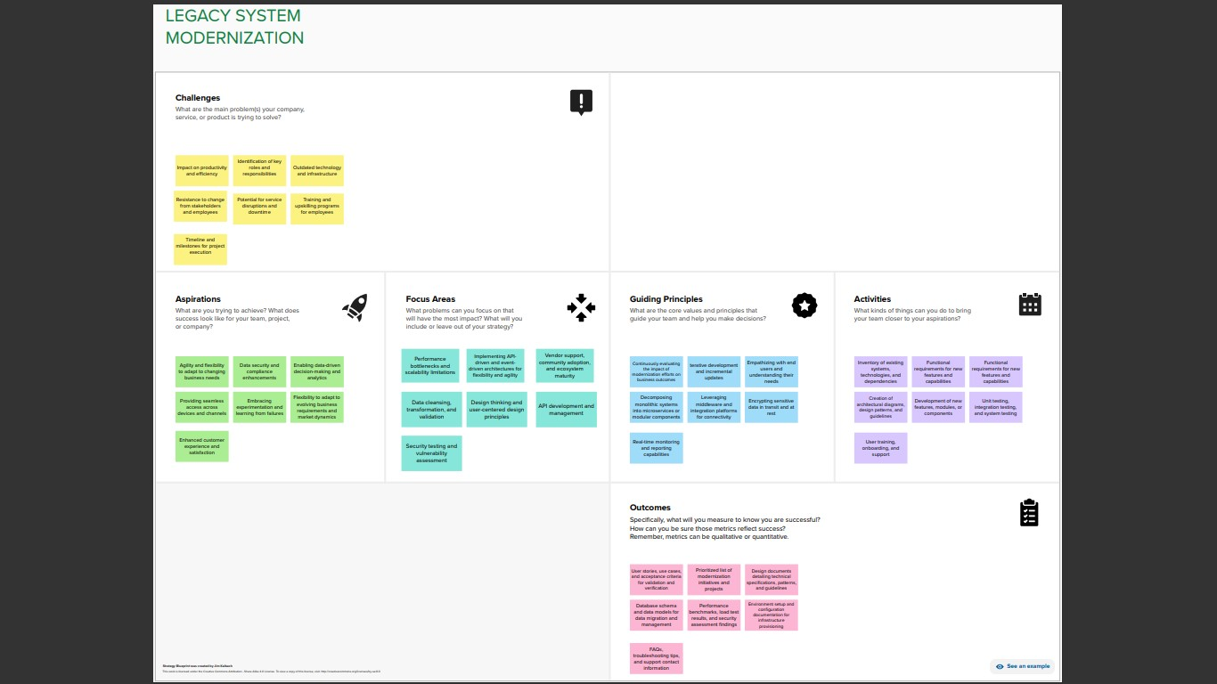

**GitHub Link:**

https://github.com/mithunakash456/DESIGN-THINKING-PROJECT.git